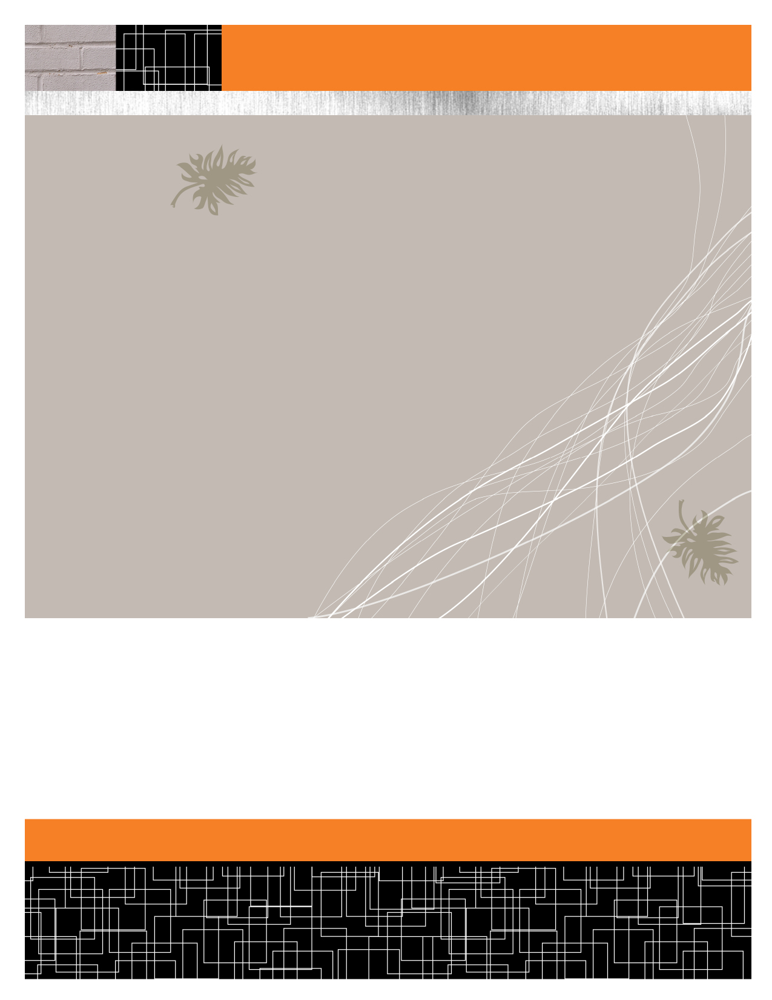

Poverty Assessment of Kibera

Doug Anderson

TUL 560

12 June 2014

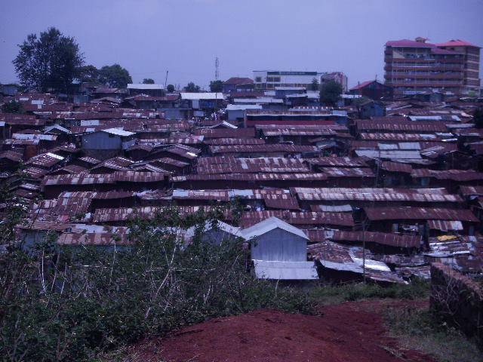

Place Photo Here,

Otherwise Delete Box

Importance of understanding poverty assessment

what does it mean to be poor?

The answer will vary greatly depending on the location, region, nation, and culture. What is considered as poverty in one area may be the equivalent of middle class in another area. Determining the level of poverty in a community is important if one is to take steps towards eradicating poverty. My colleague, Gracie Christian, and I have worked in collaboration with a local micro-finance organization called LOCAP (Local Community Awareness Program) to create a poverty assessment tool in an effort to better understand what it means to be poor in Nairobi’s Kibera slum.

creating the poverty score card

We drew our methods from several different sources. Kibera is a widely researched area; many studies have been undertaken in an attempt to understand the nature of poverty in one of the world’s largest informal settlements. Therefore, we were able to draw from different sources that analyzed the poverty index in Kenya as well as food and insecurity issues in Kibera specifically.

In conjunction with LOCAP, we created our own poverty score card based on several key elements that have been suggested to most affect a household’s poverty level (Geda, A., de Jong, N., Mwabu, G. and Mwangi S. Kimenyi, 2001). These topics include the home’s geographic location within Kibera, gender and level of education of the head of household, number of meals daily, diet type, and sources of energy and water.

We interviewed ten small business owners using these criteria and graded the responses accordingly. The higher the number, the higher the likelihood of greater poverty in a given household. Below is the score card and results.

|  |  |
| --- | --- |
| **Key** | |
| Extremely Poor | 20 to 28 |
| Moderately Poor | 11 to 19 |
| Not Poor | 0 to 10 |

|  |  |  |
| --- | --- | --- |
| **Poverty Analysis Score Card** | | |
| **Criterion** | **Options** | **Score Index** |
| Village Location | Low income Neighborhood | 4 |
|  | Medium Income Neighborhood | 2 |
|  | Higher Income Neighborhood | 0 |
| Head of Household | Female | 4 |
|  | Male | 0 |
| Head of Household Education Level | Primary or less | 4 |
|  | Secondary | 2 |
|  | University | 0 |
| Source of Energy | Paraffin | 4 |
|  | Charcoal | 3 |
|  | Gas | 2 |
|  | Electricity | 1 |
| Source of Water | Pipe-Community | 4 |
|  | Jerry Jars | 2 |
|  | Faucet (running water) | 0 |
| Number of Meals Eaten Daily | 0-1 times | 4 |
|  | 2 times | 2 |
|  | 3 times | 0 |
| Diet | Ugali and Vegetables | 4 |
|  | Ugali and Meat or Fish | 2 |

|  |  |  |  |  |  |  |  |
| --- | --- | --- | --- | --- | --- | --- | --- |
| **Survey Findings** | | | | | | | |
| **Village** | **Head of Household (HoH)** | **Education of HoH** | **Energy Source** | **Water Source** | **Meals/Day** | **Diet** | **Totals** |
| South C | Male | College | Gas | Jerry Cans | 0-1 | Ugali/Fish | **10** |
| Fort Jesus | Male | Secondary | Charcoal | Community Pipe | 3 | Ugali/Veg. | **16** |
| Karanja | Male | Secondary | Charcoal | Community Pipe | 3 | Ugali/Veg. | **15** |
| Siranga | Male | Primary | Paraffin | Community Pipe | 0-1 | Ugali/Veg. | **22** |
| Kisumu Ndogo | Male | Primary | Paraffin | Community Pipe | 2 | Ugali/Veg. | **20** |
| Lindi | Male | Primary | Paraffin | Community Pipe | 3 | Ugali/Fish/Meat | **16** |
| Lindi | Male | Secondary | Gas | Jerry Cans | 3 | Ugali/Veg. | **10** |
| Kianda | Male | Secondary | Paraffin | Community Pipe | 3 | Ugali/Veg./Gidheri | **16** |
| Gatyuakera | Male | Primary | Paraffin | Community Pipe | 2 | Ugali/Veg. | **22** |
| Gatyuakera | Male | Secondary | Electricity | Community Pipe | 3 | Rice/Ugali/Beans | **15** |



analysis of results

What does all of this mean? According to our survey of ten business people in Kibera three were “extremely poor,” five were “moderately poor,” and two were considered “not poor.” The geographic location of the village indicated a certain income bracket. The villages deeper in the slum consisted of households with lower income levels. All of the heads of households were male. 40 percent of household heads completed primary school, while 50 percent of household heads have a secondary school education. Only one person had been to college, which in Kenya is the equivalent of earning a certificate or going to a technical school. 50 percent of respondents used paraffin as a source of energy, likely because of its relatively low cost. 80 percent of respondents receive their water from community pipes. 60 percent of households reported to eating three meals per day. 20 percent of households each eat one and two meals per day respectively. Finally, this study shows that there is little variation in household diets. This is likely due to the low cost of ugali and vegetables, which 70 percent of households reported to eating on a regular basis.



disclaimer

We interviewed solely small business owners within Kibera. The majority of Kibera residents are self-employed in the economy’s informal sector, so this survey is likely an accurate reflection; however, it must be noted that it does not include responses from residents of other occupations, most notably house helps, those who commute outside of Kibera, or those who are unemployed.

An improvement to this analysis would be to conduct interviews from those of other professions. Also, all of the heads of households in our survey were male. It would be a worthwhile study to see what the living conditions are in households where females are the head and compare the difference. Other research suggests that male-led households generally have a higher income. This would have to be further quantified.



references

Faye, O., Baschieri, A., Falkingham, J. and Kanyiva Muindi. (2011). *Hunger and Food Insecurity in Nairobi's Slums: An Assessment Using IRT Models*. Journal of Urban Health: Bulletin of the New York Academy of Medicine, Vol. 88, Supple. 2. The New York Academy of Medicine.

Gallaher, C., Kerr, J., Njenga, M., Karanja, N. and Antoinette M. G. A. WinklerPrins. (2013). *Urban agriculture, social capital, and food security in the Kibera slums of Nairobi, Kenya*. Springer Science+Business Media Dordrecht.

Geda, A., de Jong, N., Mwabu, G. and Mwangi S. Kimenyi. (2001). *Determinants of Poverty in Kenya: A Household Level Analysis*. Institute of Social Studies and Kenya Institute for Public Policy Research and Analysis (KIPPRA), The Hague: The Netherlands.